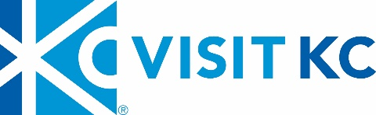

PUBLIC NOTICE

Notice is hereby given that the
Executive Committee of the Visit KC Board of Directors will conduct a meeting at 10:30 a.m. on June 20, 2017 at Visit KC Offices.

Agenda
- CALL TO ORDER

- ACTION ITEMS
- Approval of May 18, 2017 Minutes
- Board Resolution

- DISCUSSION ITEMS
- YTD Financials
- Board Survey
- Visit KC’s Business Briefing

- CLOSED SESSION

- NEW BUSINESS

- OLD BUSINESS

- ADJOURNMENT

